December 2019 DCA/Compact Staff Training Questions

## General/Other Questions

Q: What are the dates of our next ABM?

A: September 14-16, 2020

Q: Where can we download the current ICOTS user guide (*this document will be removed with the new training integration project*)?

A: Help Tab in ICOTS

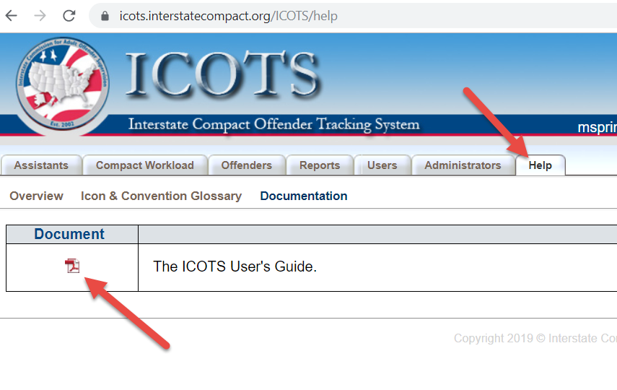

Q: Can we get a copy of the power point?

<https://support.interstatecompact.org/hc/en-us/articles/224743467-Compact-Office-Staff-Training>

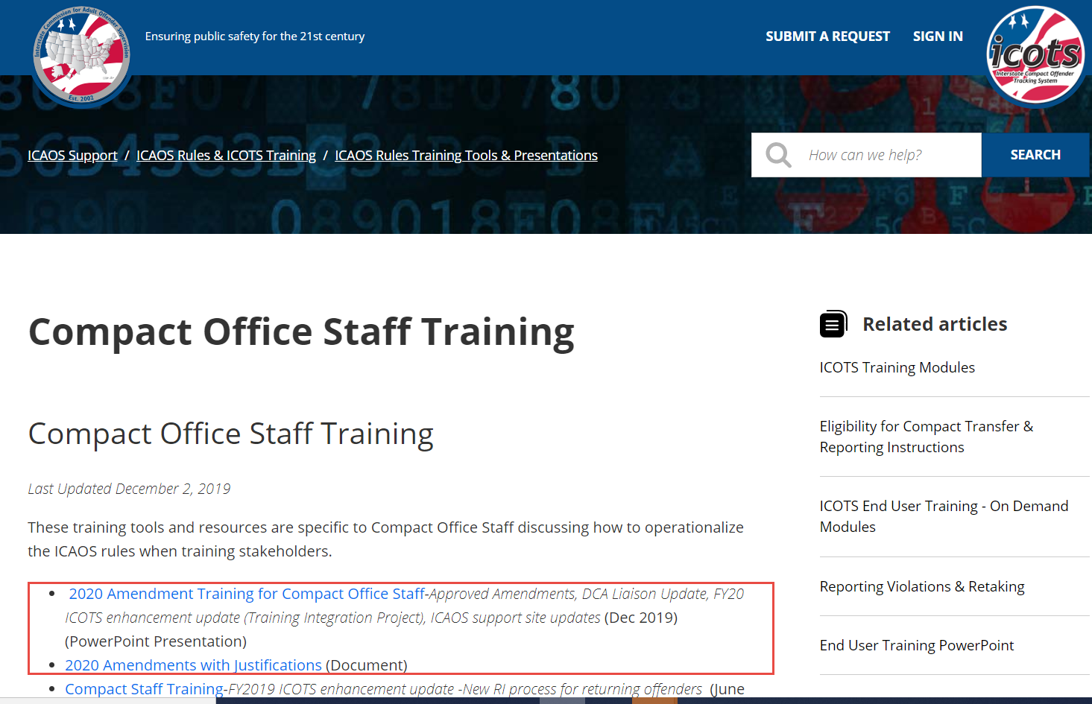

Q: Where can I find the Violation Report Type Dashboard mentioned in the training?

A: The widget shared in the training presentation is part of the Violation Summary Info Report in the ‘Activity History Dashboards.’ <https://www.interstatecompact.org/icaos-dashboards>

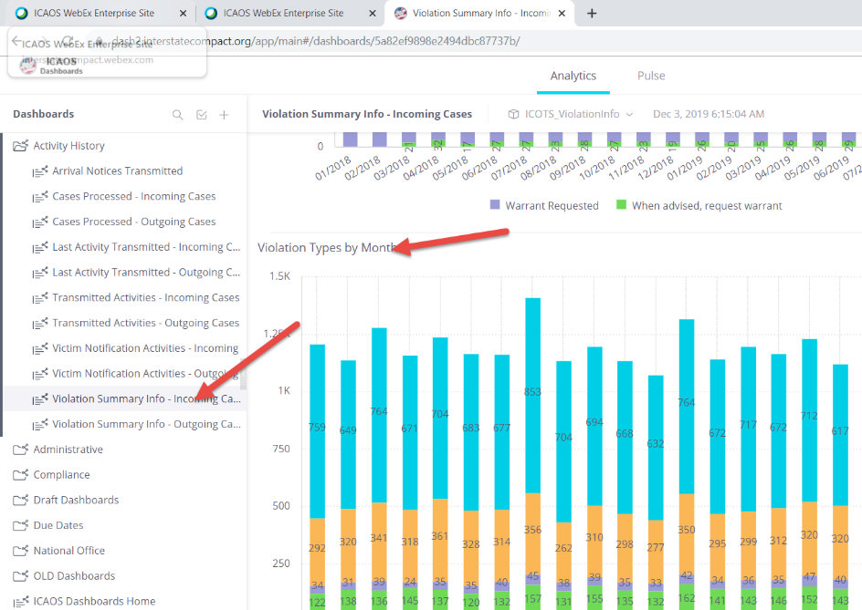

## Sex Offender Rules

Q: What about individuals who are required to register as a sex offender in the sending state for a prior offense?

A: This hasn’t changed in the amended definition, an offender can be on supervision for a non-sex offense, but meet the definition of ‘sex offender’ due to the requirement to register in the sending state. The new revised definition of ‘sex offender’ covers 3 scenarios:

* Offender who is registered in the sending state;
* Offender who is required to register in the sending state; or
* Offender who is under sex offender terms and conditions in the sending state

Q: Does Rule 3.101-3 (e) prevent an offender to travel for employment returning daily prior to issuance of reporting instructions or an acceptance?

A: No, exceptions noted in Rule 3.102 (c) & (d) are applicable to sex offenders so long as conditions outlined in the Rule are met.

Q: Will there still be a special Sex Offender status in ICOTS?

A: Yes, however the functionality/management of this status will be solely available to the sending state per the definition of ‘sex offender.’

Q: With the Return Reporting Instructions, does the sending state have 5 days to respond?

A: No, for return Reporting Instructions the sending state is required to approve/provide them within 2 business days as stated in Rule 4.111 as with any returning offenders.

Q: If the client (offender) is not required to register, but has sex offender conditions, they must wait in the sending state the 5 business days when a RFRI is submitted?

A: Yes. See Q & A above. There are 3 scenarios in which an offender can meet the definition of sex offender.

Q: Regarding sex offenders, the narrative/charge summary is extremely helpful in the supervision aspect as it relates to treatment. some states only submit a statement of charges because that’s all they have. How can we obtain the documentation we need?

A: Rule 3.101-3 (b)(3) specifically requires the sending state’s current or recommended supervision and treatment plan. Once an offender is accepted for supervision in a receiving state, the receiving state may request any documentation that may be available in the sending state to assist in the supervision of that offender. See Rule 3.101-3 (c), (d) and 3.107 (c). It is expected of states to provide good documentation and communication in ALL transfers. States withholding or refusing to provide information simply because ‘it’s not required by Rule’ are not applying the Compact Rules as stated in their statute. If the receiving state believes there is information that is relevant, requested and is not provided by a sending state, this matter should be escalated. *Reminder: The ICOTS Whitepaper published Dec 2018 speaks to the matter too of ‘good documentation’ and as DCAs, you are custodian of your state’s data and responsible for what goes into ICOTS and what does not if withheld inappropriately. “Moreover, since the compact states are the ‘owners’ of the information that is submitted to ICOTS, the compact states are responsible for the accuracy of the data and are best able to vouch for its reliability.”*

## Victim Rules

Q: I had victim representatives in our state council voice concern that this reduces the amount of notification required by states. Would you agree with that?

A: No, the revisions to Rules 3.108, 3.108-1, and newly adopted Rule 3.110 actually EXPAND notifications. The receiving state notifications required to be made under current Rule 3.108 (b)(1)(A), (B), (C) & (D) are facilitated via other Rule requirements. Section (E) has expanded notifications when travel permits are issued to ANY offender when travelling back to a sending state, not just those currently deemed ‘victim sensitive’ which is also a known data element to be utilized inconsistently/inaccurately.

Q: I'm not clear as to why a sending state would or should check victim sensitive unless they have a registered victim. If I heard correctly, the sending state can check that box for let's say an NCO or maybe a shoplifting or embezzlement victim such as Wal-mart, etc. So the special status of Victim Sensitive will no longer mean an actual "registered" victim?

A: As indicated in the previous question’s answer, the ‘victim sensitive’ indicator has not been consistently/correctly applied in relation to a sending state’s victim notification process since the launch of ICOTS. The Commission voted at the 2019 ABM to keep the indicator in ICOTS for states to utilize, however it no longer has a national standard for its use. Sending states will need to determine and train on its use as it best fits their use.

## Rule 3.110 Travel Permits

Q: What if a state does not issue travel permits, and allows offenders to travel among states with verbal permission only?

A: This new rule was not intended to exclude such situations; however, the definition of travel permit does read as follows: “*Travel permit” means the written permission granted to an offender authorizing the offender to travel from one state to another.* As this scenario was not part of any known conversation/posted comment during the rule adoption process, the trainers will seek guidance from the Rules Committee and try to report back on this matter at the upcoming training in February 2020. In the meantime, the Rule does not prevent states from providing additional notifications above the rule requirement. (*this rule should be implemented in accordance with each individual state’s policies)*

*December 18, 2019 update: The Rules Committee discussed the amendment’s intentions and definition that may exclude travel notifications when verbal or no permission is required for travel back to a sending state. The Rules Committee requested DCA Liaison Committee regions collect the DCA’s feedback whether there could be problems with implementation of this rule. The DCA Liaison Chair will report findings back to the committee to determine if it a true issue exists for states before taking any additional steps.*

Q: Does the receiving state need to wait for the sending state to respond to the notification about the travel permit before the offender is allowed to proceed?

A: No, the rule does not require approval or response from the sending state.

Q: Does this have to be submitted via Compact Action Request or can the travel permit be sent through the compact office?

A: The rule is silent on the manner in which the notification must take place. As every state operates differently, receiving states should enforce this rule within their existing travel permit policies and are responsible for its enforcement and compliance.

Q: Is travel to attend school/higher education covered under (b)(1)?

A: No, the rule only speaks to work or medical appointments as exceptions for travel that do not require notification. Those specific exceptions were added to be consistent with exceptions found in Rule 3.102. As any situation not specifically covered by a rule, it’s important for states to communicate with one another. Receiving states should work with sending states when situation such as this arise. For example, if there is a victim involved, the sending state may want/need to know every time the offender is coming into their state so the victim can be notified. In other cases, the initial notification that the offender will be attending school over the next 3-4 months in your state, (providing the schedule for that travel) this initial notification may suffice. Considering the exceptions that do exist in the rule (work & medical appts) states may encounter cases in which they deem it’s a good idea to notify in those instance due to the circumstances of the offender’s supervision. The rule doesn’t prevent those notifications; it just doesn’t require them.

## Rule 5.101 Discretionary Retaking

Q: Does within 15 business days of the directive to the offender mean the sending state could have notified the offender 3 weeks prior to notifying the receiving state?

A: When training staff on this rule, states must consider the application of this rule in context to how their state orders offenders to return. It is certainly not the intent of this new language to allow a sending state to wait 3 weeks to notify a receiving state AFTER the offender has received his or her directive. The importance of this notification is primarily to:

* Ensure the receiving state is informed so they can properly request reporting instructions and track the movement of the offender back to the sending state; and
* Address safety concerns of the public, officers and victims

Typically, an offender is ordered to return under this rule via summons from a court. What is occurring now is a sending state’s failure to provide ANY notification for the return. (The court makes the summons, the officer in the sending state is informed, but stops short there; the receiving state is never notified and return reporting instructions and that movement is not being tracked as Rule 4.111 requires.)

An example of how this new language intends to close this gap in communication would be:

* On December 2nd 2019 a court in my state (sending state) summons an offender to return for a court date on January 15th, 2020
* The Sending State is REQUIRED (per this new language) to inform the receiving state of this directive no later than December 23rd, 2019.
* This in turn gives the receiving state plenty of time to confirm the offender’s travel plans and request Reporting Instructions (which of course should be requested at least 2 or more business days (but the sooner the better!) to ensure a response is received before the offender needs to travel

Q: Is it problematic that a sending state speak to the offender about revocation matters prior to speaking to the receiving state? Maybe the first order would be the sending state speaks to the receiving state first.

A: See safety concerns noted in above question and in the justification for this rule amendment. The sooner the receiving state can be informed, the better. Anytime a rule is applied, public safety concerns should be top priority. States need to evaluate their processes for how/when/what circumstances Rule 5.101 may be applied and ensure these notifications are taking place in a timely manner.

## Rule 5.103 Offender Behavior Requiring Retaking

Q: If we are unable to apprehend the offender should the Absconder Violation Report be done as an addendum or as a whole new Violation Report?

A: After a report of behavior requiring retaking and the offender is subsequently deemed an absconder, a NEW Violation Report is required. This also allows for a case closure, indicating the receiving state is no longer supervising this offender due to his/her whereabouts being unknown.